**2D Transformations (part 4)**

***Code:***

import cv2

import numpy as np

import matplotlib.pyplot as plt

# Source for translation and rotation commands (https://learnopencv.com/image-rotation-and-translation-using-opencv/)

def transform(image):

# translate the image by (30, 100)

M_1 = np.float32([[1, 0, 30], [0, 1, 100]])

translated = cv2.warpAffine(image, M_1, (300, 300))

# rotate the image by 45 degrees about the center

M_2 = cv2.getRotationMatrix2D((150, 150), 45, 1)

rotated = cv2.warpAffine(translated, M_2, (300, 300))

plt.imshow(cv2.cvtColor(rotated, cv2.COLOR_BGR2RGB))

plt.title('rotated & translated Quadrilateral')

plt.axis('off')

plt.show()

# Make the 300x300 image

image = np.zeros((300,300,3), dtype=np.uint8)

# Create a white irregular quadrilateral of 50x50 in size

corners = np.array([[120, 140], [170, 140], [175, 170], [125, 180]] , np.int32)

# fill the quadrilateral white

cv2.fillPoly(image, [corners], (255, 255, 255))

plt.imshow(cv2.fillPoly(image, [corners], (255, 255, 255)))

plt.title('original Quadrilateral')

plt.axis('off')

plt.show()

transform(image)

***Output:***

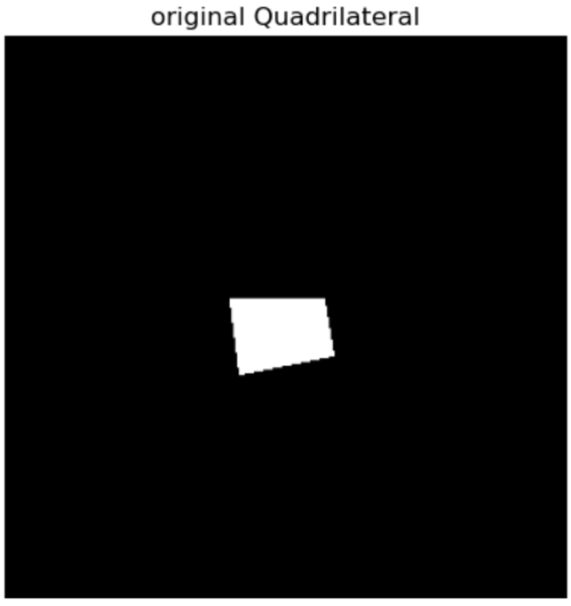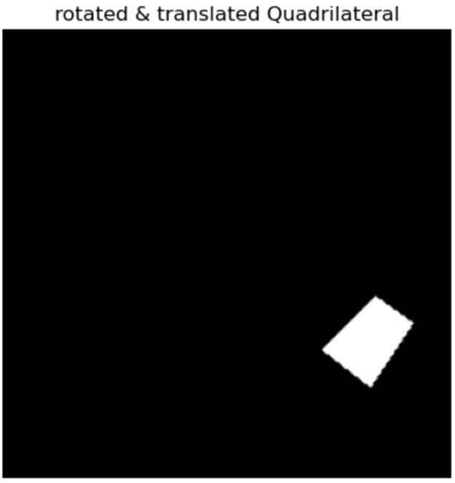

**Writing your Own Image Stitching Algorithm**

***-------------------------------------------- computeH() function code:***

def computeH(im1_pts, im2_pts):

M = []

for i in range(len(im1_pts)):

x, y = im1_pts[i][0], im1_pts[i][1]

xp, yp = im2_pts[i][0], im2_pts[i][1]

M.append([-x, -y, -1, 0, 0, 0, x*xp, y*xp, xp])

M.append([0, 0, 0, -x, -y, -1, x*yp, y*yp, yp])

M = np.array(M)

U, s, Vt = np.linalg.svd(M)

H = Vt[-1].reshape(3, 3)

H = H / H[2, 2]

return H

***--------------------------------------------- ransac() function code:***

def ransac(corr, thresh, itera):

max_inliers = []

best_H = None

for i in range(itera):

idx = np.random.choice(len(corr), 4, replace=False)

pic1_pts = np.float32([corr[i][0] for i in idx])

pic2_pts = np.float32([corr[i][1] for i in idx])

H = computeH(pic1_pts, pic2_pts)

inliers = []

for (pt1, pt2) in corr:

homog_pt1 = np.append(pt1, 1)

estimated_pt2 = np.dot(H, homog_pt1)

estimated_pt2 /= estimated_pt2[2]

dist = np.linalg.norm(estimated_pt2[:2] - pt2)

if dist < thresh:

inliers.append((pt1, pt2))

if len(inliers) > len(max_inliers):

max_inliers = inliers

best_H = H

return best_H

***----------------- estimateH() function code for estimating homography:***

def estimateH(image1_path, image2_path):

images = [cv2.imread(image1_path), cv2.imread(image2_path)]

sift = cv2.SIFT_create()

# Detect keypoints and compute descriptors for each image

kp1, des1 = sift.detectAndCompute(images[0], None)

kp2, des2 = sift.detectAndCompute(images[1], None)

# Draw keypoints on images & Display images with keypoints

img1_kp = cv2.drawKeypoints(images[0], kp1, None)

img2_kp = cv2.drawKeypoints(images[1], kp2, None)

# match and sort descriptors

bf = cv2.BFMatcher(cv2.NORM_L2, crossCheck=True)

matches = bf.match(des1, des2)

matches = sorted(matches, key=lambda x: x.distance)

# Draw the top N matches

N = 100

img_matches_bf = cv2.drawMatches(images[0], kp1, images[1], kp2, matches[:N], None)

good_matches = [m for m in matches if m.distance < 300]

src_points = np.float32([kp1[m.queryIdx].pt for m in matches]).reshape(-1, 1, 2)

dst_points = np.float32([kp2[m.trainIdx].pt for m in matches]).reshape(-1, 1, 2)

corr = np.concatenate((src_points, dst_points), axis=1)

H = ransac(corr, thresh=5, itera=1000)

return H, img1_kp, img2_kp, img_matches_bf

***------------------------------------------------- stitching_2() code:***

def stitching2(img1, img2, H):

img1 = cv2.imread(img1)

img2 = cv2.imread(img2)

# Note img_2 is the reference image here

offset = 0.6

extension = 200

shift_y = 100

# Max height and total width

canvasH = max(img1.shape[0], img2.shape[0]) + extension

canvasW = img1.shape[1] + img2.shape[1] + extension

# Translation

shift = np.array([[1, 0, offset*img2.shape[1]], [0, 1, shift_y], [0, 0, 1]])

adjusted_H = shift @ H

# Warp img_1

warped_img = cv2.warpPerspective(img1, adjusted_H, (canvasW, canvasH)).astype(np.float32)

# Create the blank canvas and put the reference image on it

canvas = np.zeros((canvasH, canvasW, 3), dtype=np.float32)

canvas[shift_y:img2.shape[0]+shift_y, int(offset*img2.shape[1]):int((1+offset)*img2.shape[1])] = img2

# Form final stitch by adding the warped image to the canvas

final_stitch = canvas + warped_img

# Normalize pixel values to the range [0, 255]

final_stitch = np.clip(final_stitch, 0, 255).astype(np.uint8)

return final_stitch

***------------------------------------------------- stitching_3 code:***

def stitching3(img1, img2, img3, H1, H2):

img1 = cv2.imread(img1)

img2 = cv2.imread(img2)

img3 = cv2.imread(img3)

# Note img_2 is the reference image here

offset = 0.6

extension = 200

shift_y = 100

# Max height and total width

canvasH = max(img1.shape[0], img2.shape[0]) + extension

canvasW = img1.shape[1] + img2.shape[1] + extension

# Translation for img 1

shift = np.array([[1, 0, offset*img2.shape[1]], [0, 1, shift_y], [0, 0, 1]])

adjusted_H = shift @ H1

# Warp img_1

warped_img = cv2.warpPerspective(img1, adjusted_H, (canvasW, canvasH)).astype(np.float32)

# Translation for img3

shift2 = np.array([[1, 0, offset*img2.shape[1]], [0, 1, shift_y], [0, 0, 1]])

adjusted_H3 = shift2 @ H2

# Warp img_3

warped_img2 = cv2.warpPerspective(img3, adjusted_H3, (canvasW, canvasH)).astype(np.float32)

# Create the blank canvas and put the reference image on it

canvas = np.zeros((canvasH, canvasW, 3), dtype=np.float32)

canvas[shift_y:img2.shape[0]+shift_y, int(offset*img2.shape[1]):int((1+offset)*img2.shape[1])] = img2

# Form final stitch by adding the warped image to the canvas

final_stitch = canvas + warped_img + warped_img2

# Normalize pixel values to the range [0, 255]

final_stitch = np.clip(final_stitch, 0, 255).astype(np.uint8)

return final_stitch

***---------- Code utilizing all these functions for submission outputs:***

image1 = "/Users/fneba/Desktop/Hw3/keble_a.jpg"

image2 = "/Users/fneba/Desktop/Hw3/keble_c.jpg"

reference = "/Users/fneba/Desktop/Hw3/keble_b.jpg"

Homography, img1_kp, img2_kp, img_matches_bf = estimateH(image1, reference)

Homography2, img1_kp2, img2_kp2, img_matches_bf2 = estimateH(image2, reference)

# From image 1 and reference

cv2.imshow('Image 1 KP', img1_kp)

cv2.imshow('Reference KP', img2_kp)

cv2.imshow('Brute-Force Matching', img_matches_bf)

# From image 2 and reference

cv2.imshow('Image 2 KP', img1_kp2)

cv2.imshow('Reference KP', img2_kp2)

cv2.imshow('Brute-Force Matching', img_matches_bf2)

# Create the mosaic from two images and their homography

mosaic1 = stitching2(image1, reference, Homography)

mosaic2 = stitching2(image2, reference, Homography2)

# Show the resulting 2 image mosaic (image 1 and ref)

cv2.imshow("Mosaic1", mosaic1)

# Show the resulting 2 image mosaic (image 2 and ref)

cv2.imshow("Mosaic2", mosaic1)

# Create the panorama from 3 images and their homographies

panorama = stitching3(image1, reference, image2, Homography, Homography2)

# Show the resulting 3 image mosaic

cv2.imshow("Panorama", panorama)

cv2.waitKey(0)

cv2.destroyAllWindows()

cv2.waitKey()

***Outputs:***

**Raw matches & visualization of tentative matches & inliers for each pair (image 1 and reference):**

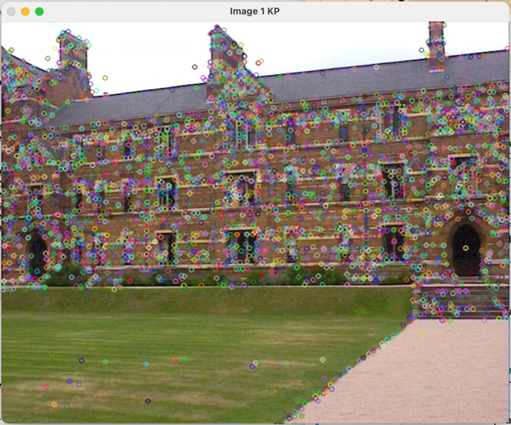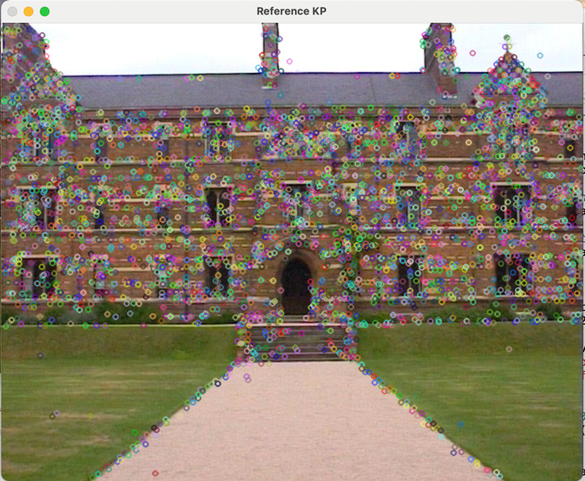

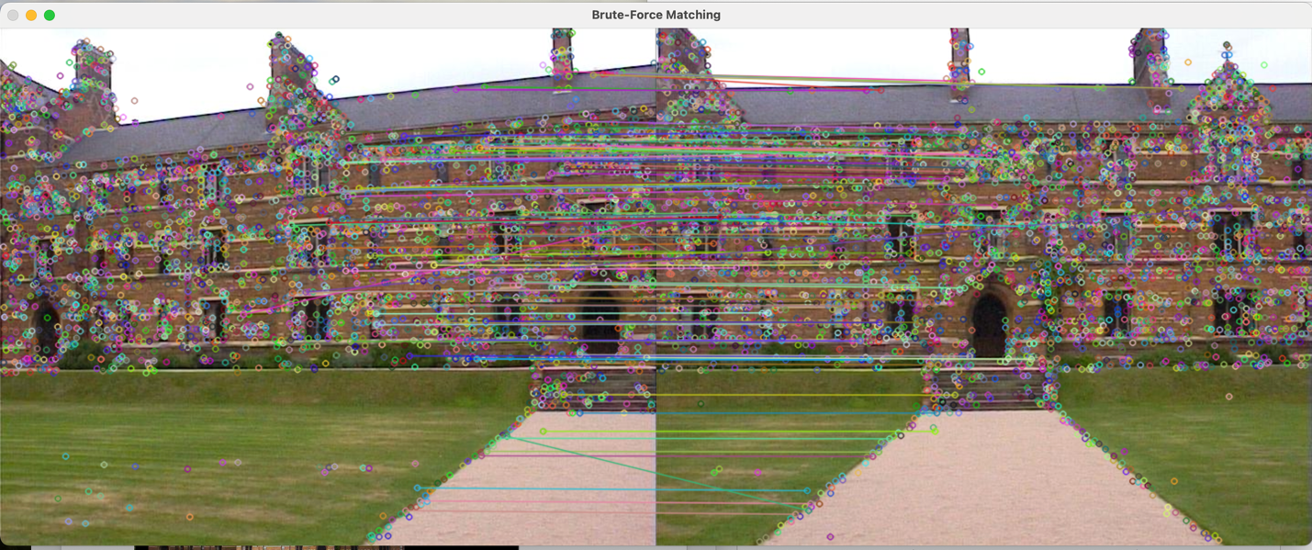

**Raw matches & visualization of tentative matches & inliers for each pair (image 2 and reference):**

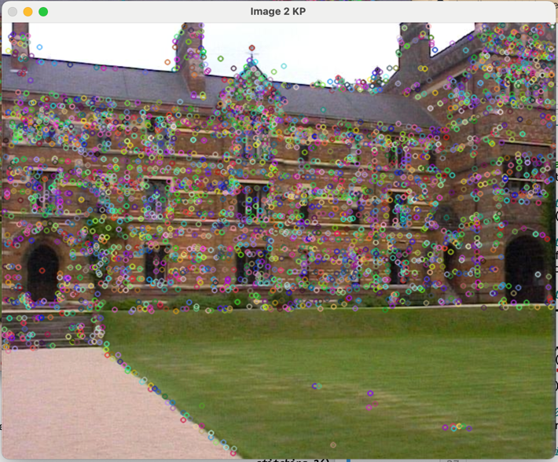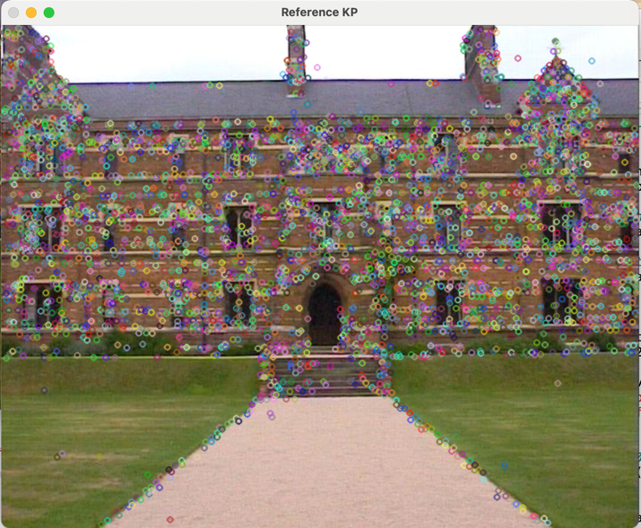

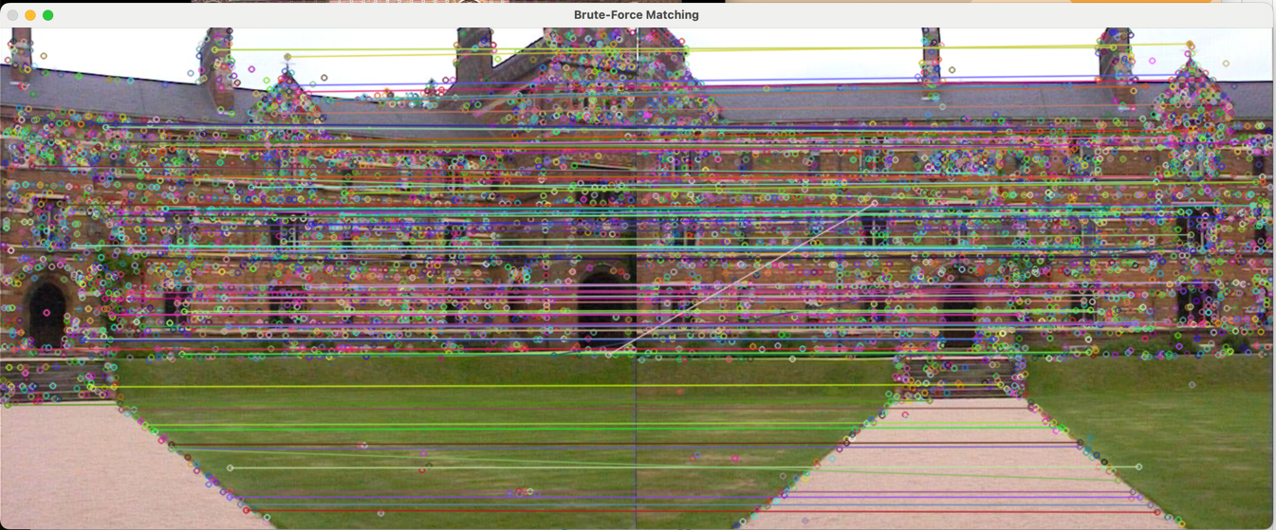

**Output of stitching 2 images:**

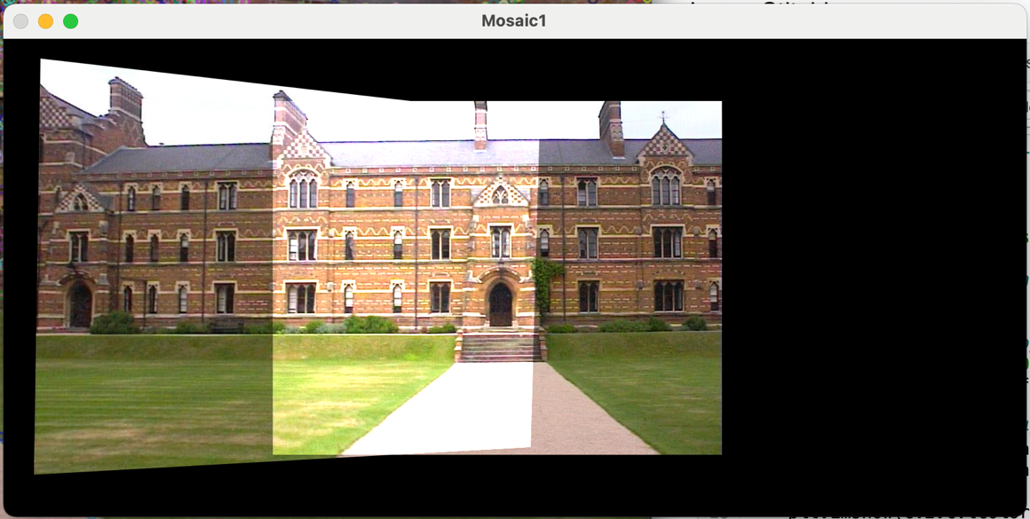

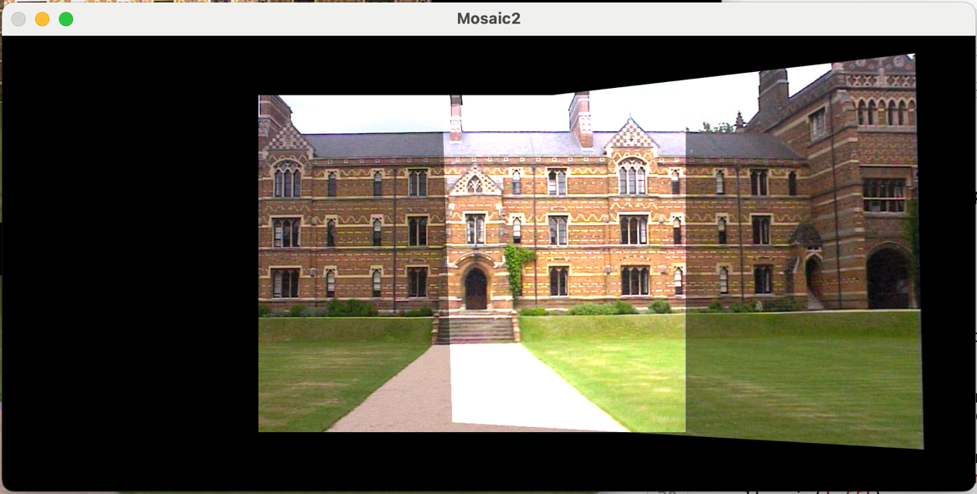

***Final mosaic (or in this case, I called it panorama):***

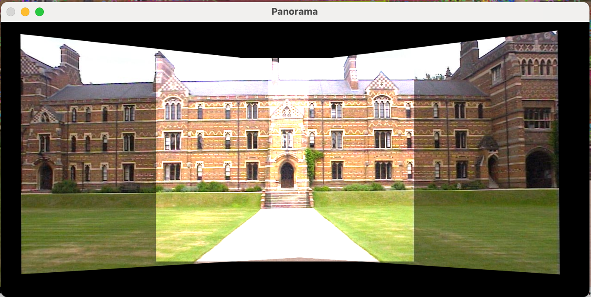

***------------------------ Extra Credit Part 1 function for “cropping”:***

def crop_panorama(panorama):

grayscale = cv2.cvtColor(panorama, cv2.COLOR_BGR2GRAY)

_, thresh = cv2.threshold(grayscale, 1, 255, cv2.THRESH_BINARY)

# Find spots where there are non-black pixels

NB = np.argwhere(thresh > 0)

# Get bounding box for this non-black area

y1, x1 = NB.min(axis=0)

y2, x2 = NB.max(axis=0) + 1

# The actual cropping

cropping = panorama[y1:y2, x1:x2]

return cropping

panorama = crop_panorama(panorama)

cv2.imshow("Panorama", panorama)

***Output from using code on the original panorama:***

